Improving student learning by combining accessibility/inclusion with academic integrity

Student Academic Integrity CHAMPION model

This model is designed to assist staff in developing the institutional role of Student Academic Integrity Champions.

It involves 8 stages of development, using the acronym CHAMPION as follows:

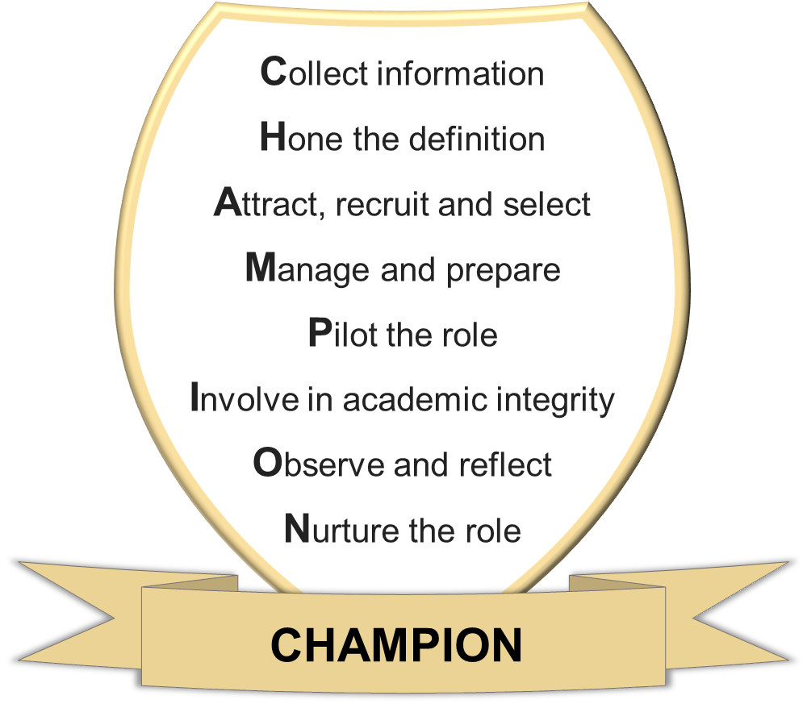

In order to complete the stages of development, we offer key questions to consider and possible responses to facilitate the decisions that need to be made by institutions.

The stages, questions and recommendations or possibilities have been developed through our project by analysing our data from student focus groups across our four institutions and discussing the emerging trends in depth.

Stage of development | Considerations for each stage to develop Student Academic Integrity Champion (SAIC)
COLLECT INFORMATION | - What does your institution need, in terms of a student role in academic integrity?  Possibilities: Staff and student feedback, for example over-representation of particular student groups in academic integrity issues; the need to support academic transition and belonging.  - How can the role of SAIC fit with existing structures and student roles at your institution?  Possibilities: Structures such as SU, Library; roles such as student partners, student reps, student ambassadors, PALs, other student champions.
HONE THE DEFINITION | - How do you want to define SAICs in your institution?  Recommendations: Primary role to promote academic integrity to students, to signpost students to support or resources, or to work with staff.  - What activities should be included in the SAIC role?  Possibilities: Promoting, producing resources such as videos or FAQs, signposting to students, events, use of social media.  - How can you co-create the role with students? Possibilities: Through focus groups, questionnaires, liaison with SU, Student Advisory Boards.
ATTRACT, RECRUIT AND SELECT | - How do you want to promote the role?  Possibilities: Through channels such as the VLE, in-class call-outs, through SU communications, institutional student communications, social media.  - Will you try to have representation across disciplines, levels and student groups?  Possibilities: SAIC from each Faculty/School, different levels of Foundation/UG/ PGT/ PGR, peer assistants, alumni, international/home, neurodiverse, other under-represented groups in the student body.  - Will you require applicants to submit an expression of interest?  Possibilities: Ask applicants to write a paragraph to explain their motivation to take on this role; request a tutor recommendation.  - How will SAICs benefit from the role?  Recommendations: SAICs will develop transferable skills towards employability and further study. All SAICs should receive a certificate and/or reference. Payment is encouraged if the role can fit with existing paid roles in the institution.

MANAGE AND PREPARE | - Who will manage the SAICs?  Possibilities: Academic/administrative staff in academic integrity roles.  - What does the preparation and training need to cover?  Recommendations: Awareness of regulations, procedures and advice; effective communication to signpost and promote academic integrity; how to explain the importance of academic integrity beyond assignments including for employability; co-creation of ideas with SAICs.
PILOT THE ROLE | - Which specific tasks can you ask the first SAICs to do in the role as a pilot?  Possibilities: Make videos, write social media posts, get feedback from students about their role.  - How long should the pilot stage last?  Recommendations: 2-3 months or one term/semester.
INVOLVE IN ACADEMIC INTEGRITY | - How can you involve SAICs in academic integrity? Recommendations: Community building, creating safe spaces for discussion, working with staff on producing video resources, co-producing blogs, promoting academic integrity to students via social media, working with champions in similar roles.  - How will you establish the boundaries of the SAIC role?  Recommendation: Decide where SAICs should refer onto staff.
OBSERVE AND REFLECT | - How can you support the champions?  Recommendations: Establish how to contact and have regular meetings with SAICs, ensure flexibility in the role, and that any problems can be dealt with.  - How can you evaluate the role?  Possibilities: Monitor output, gather feedback from students and SAICs, assess impact on academic integrity.
NURTURE THE ROLE | - How can you ensure the role has an impact on academic integrity at your institution?  Possibilities: Publicise the role, celebrate success, produce records of SAIC engagement, involve in course committees and faculty structure.  - How can you maintain the SAIC role so that it continues each year?  Possibilities: Give rewards such as certificates, references, payment; enable succession planning through champions offering training to other students for the following year.
Note: SU denotes Student Union or similar organisations such as Student Guild
For further information, please contact the Project lead: Dr Mary Davis at marydavis@brookes.ac.uk
This model is an output from a Collaborative Enhancement Project supported and funded by QAA Membership. The project is led by Oxford Brookes University in partnership with Bloomsbury Institute, University of Southampton and University of Westminster. Find out more about Collaborative Enhancement Projects on the QAA website.

