Improving student learning by combining accessibility/inclusion with academic integrity

This project brings together inclusion and academic integrity. We define inclusion as follows: Inclusion involves celebrating differences in all aspects of who we are as individuals with every person respected, valued and supported. We aim to integrate it within our practice to enhance engagement, participation, learning and choice for all.

Snakes and Ladders: Encourage good academic practice and avoid problems with academic integrity

Information for instructors

Type of activity | Game
Mode of delivery | In-person, hybrid, online.
Aim | To encourage students to follow good academic practice and raise their awareness of possible academic conduct problems to avoid.
Suitable for | Students at an early stage of their studies, such as before their first main assignment to help them prepare.  Students at a later stage of their studies to help reinforce good practice
Resources | Questions, example game board, links for adaptation
Time | Approx. 45-60 minutes.

Context
First invented by Hindu Spiritual leaders in ancient India, this board game has a complex evolution which symbolises difficult journeys evident in history (Topside, 1985). Its educational context is simple: good deeds are rewarded (by climbing ladders to progress through the game quickly), while snakes are a bad omen (Fita et al., 2010), traditionally representing negative behaviours which are associated with misfortune (sliding back closer to the start of the game).

Rules of the game
The numbers of the board represent days (time): Day 1 is when the question/assessment detail is released. Day 100 is the submission date. Working on the assumption that players have 100 days to complete their essay/ report/ assignment, they should take it in turns to throw the dice and move their character (ideally, something which symbolises success e.g., a graduation hat, trophy, or rolled up degree certificate) up the appropriate number of squares. If their character lands on a number detailing a ‘positive academic practice’, this will be located at the base of a ladder, and they can move to the top (progressing further through the game). If, however they land on a number detailing a ‘negative academic practice’ at the head of a snake, they slide down to the lower number at the base of the tail (where a reminder lesson linked to avoiding academic integrity issues is shared).
When a six is rolled, the player is rewarded with two attempts. The game continues until the penultimate player reaches day 100: symbolising completion of all the work without being negative impacted by issues of academic integrity.

Goal
To reach Day 100 – complete and submit your assignment using good academic practices. Key to learning when conducting this game is that there is a definitive end point. Players are expected to reach Day 100 (their submission deadline) following good academic practice. If they do, they should gain a good grade, pass, and progress. Learning from and overcoming challenges met along the way is feasible. The level of success achieved for their submitted work however will highlight the degree of attainment in each area of good practice included on the board.

Accessibility/ inclusion considerations
- Online versions of this game may be difficult to read for students using a screen-reader as it tends to be structured from bottom to top of page, and variably from left to right then right to left. To account for this, free-screen-reader software (e.g., Tolk: Click here) could be used to determine where text strings are included, routing the user to the appropriate screen-reader and ‘next step’ in the game.
- Colours/ graphics are proposed to identify positive and negative academic practices.
  - In digital versions, over-writing with auditory cues could be integrated.
  - For hard copy versions of the game, tactile squares could be used (e.g., rough/ sandpaper for snakes, smooth plastic panels for ladder designs).
  - Symbols could also be utilised to identify positive/ negative practices where colours are preferred for use (hard board and digital versions).
- Tactile dice for blind users (of hard-board game). E.g., Click here

The topic: Students will usually be expected to write at least one essay during their degree. They are an effective way to demonstrate advanced cognitive skills. They require students to research and critically assess knowledge; organise it in a coherent structure; and use it to present an argument or answer a question.
Purpose of an essay: To present a logical, reasoned argument in response to a particular question/ topic.
Goal(s) of this game: To develop good academic practice for tackling assessments. To avoid issues relating to academic integrity and achieve high grades in a time-efficient manner.

Practices to reward (ladders)
LADDERS (Bottom of) | LADDERS (Top of – reward noted/ behaviour encouraged)
Start work on the essay early. | Well done! More time to work on your submission will facilitate development of broader and deeper insights.
Read the assignment brief and marking criteria carefully. | It’s always a good idea to check and recheck what you need to do before you start. Well done.
Attended the assessment introduction workshop. | Great! Take every opportunity to ask question and hear what others are thinking.
Asked questions on the module discussion board. | Excellent idea – direct your questions to the person who will be marking your work!
Dissected the question: I know what this process word means | Process words tell you what is required of you when answering essay questions, so show you how to use the information you find for your essay.
Identify and use sources relevant to the topic (used the directed materials first). | Information can be found in lots of different places (e.g., newspapers, books, journal articles, encyclopaedias, web pages). The type of information you need will depend on the question you are trying to answer, always aim to use credible sources.
Aiming to show awareness of how this information informs my argument. | Remember that your assessor needs to understand how the evidence you have cited helps explain your included points.
Referencing? I’ve kept great notes of where I read what. | Well done. It’s vital that the source you reference actually supports the point you make – so cite as you write!
Clear thread for my arguments/ content. | Lots of information can seem relevant, but how you show its importance to your story/ argument will help you to demonstrate your understanding.

Practices to avoid (snakes)
SNAKES (head of) | SNAKES (tail of, reminder of why this is a bad idea…)
Don't leave writing to the last minute! | You might think you work better under pressure, but leave enough time to reflect on your draft, add detail needed to gain clarity and marks.
Ignore the marking criteria/ rubric. | We mark you against a published rubric – if you don’t demonstrate attainment of this, you might fail…
Missed the assessment introduction workshop. | Missed opportunity… This might be your only chance to check you understand what you need to do.
Asked questions on our WhatsApp group chat! | Your friends are great, but they are not marking your work… how can you know if they are right?
Essays are descriptions of a topic, I’ve got this! | Good essays need to do much more than describe… did you read the marking rubric?
No idea what this means… I’ll google it. | Google is amazing, but it doesn’t always contain the answer you need. Can you think of better ways to ask your questions?
Trust the top hits on google. No time to read the original research… | Google ‘hits’ link to how you use your computer. Previous websites visited, your geographic location, the device you are searching from. Will the google algorithm linked to your search find what your assessor is expecting in the essay?
Where did I read that again? It’s my idea, no need to reference anyone! | You might think your assessor won’t check, but they know the topics they are assessing you on well. Make sure you keep good notes!
Copy, cut, paste… I can’t write that as well as them. | This is plagiarism. You could end up with an academic breach and a mark of zero…
I’ve no time to do this. I’m going to borrow my friend’s draft. | This is collusion. If you use their work, you could lead to both your work and your friend’s being reported to academic quality.
I’ve no time to do this. I’m going to use an essay mill. | The essays on these sites are not always very good. They are likely to be ‘matched’ on plagiarism software too. The reason you’re being assessed on this is because you need to demonstrate attainment of these skills – this decision could make you less likely to succeed in your chosen career.

Adaptations you could add to your game:
Add links to pages from your institution where good academic practices are encouraged. University of Westminster library:
- Research (peer reviewed literature) reading a journal article
- Devise an argument and develop criticality
- Structure your essay

Design points to note
- Digitalisation of new materials
- Templates are ready to go and can be adapted - see below (can blow up cut out dice Click here and printable board Click here for face to face teaching)
Design provided for illustration purposes only, available from: https://www.howtofixx.com/snakes-and-ladders-template/

References
Fita, D.S., Neto, E.C.M. & Schiavetti, A. (2010) Offensive' snakes: cultural beliefs and practices related to snakebites in a Brazilian rural settlement. Journal of Ethnobiology and Ethnomedicine 6:13. https://ethnobiomed.biomedcentral.com/articles/10.1186/1746-4269-6-13
Topside, A. (1985) The Indian game of snakes and ladders. Artibus Asiae, 46(3): 203-226.

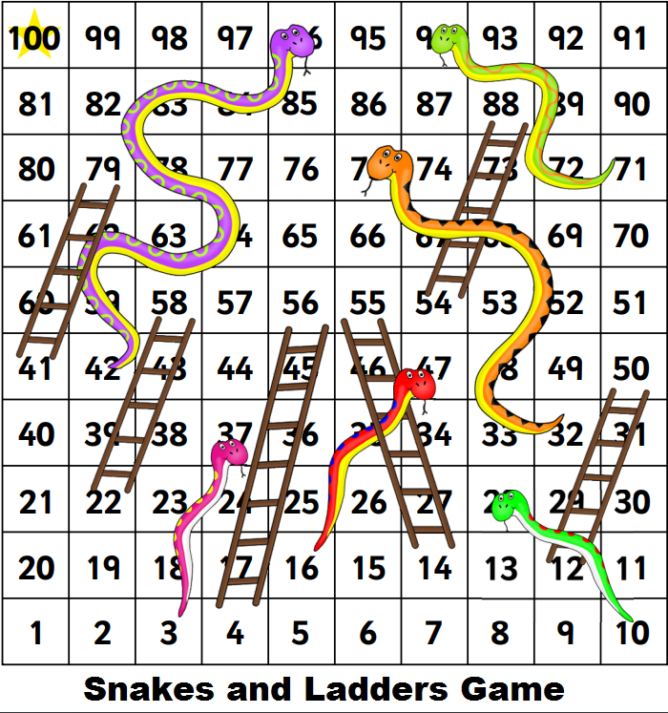
This exercise is an output from a Collaborative Enhancement Project supported and funded by QAA Membership. The project is led by Oxford Brookes University in partnership with Bloomsbury Institute, University of Southampton and University of Westminster. Find out more about Collaborative Enhancement Projects on the QAA website.

For further information, contact the Project Institutional Lead Stephen Bunbury: bunburs@westminster.ac.uk

