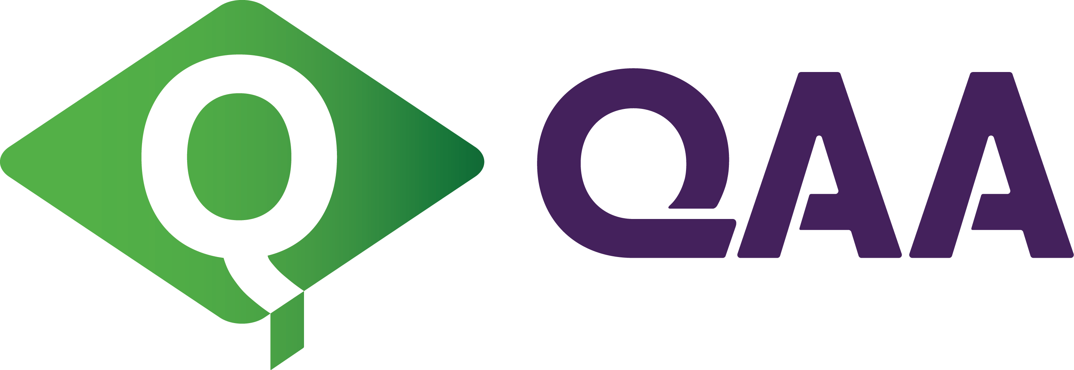

Appendix 1: AVA Appeal Submission Form
This document is also available in Welsh on the QAA website.
Name of organisation submitting appeal
Address of organisation submitting appeal

Judgement(s) being appealed  (see note (i) below) | Tick if appealing on grounds of 'Procedure'  (see note (ii) below) | Tick if appealing on grounds of  'New Material'  (see note (iii) below)
Note (i) Only recommendations made to the QAA Board: that an AVA Licence should be refused; that an AVA licence should be withdrawn; or, for the time period of an AVA licence can be appealed, and one or two grounds in support of the appeal must be indicated (see notes (ii) and (iii) below).
Note (ii) 'Procedure' refers to an irregularity in the conduct of the licensing activity such that the legitimacy of the decision(s) reached is/are called into question.
Note (iii) 'New Material' refers to material that was in existence at the time the decision was made which, had it been made available before the licensing activity had been completed, would have influenced the recommendations, and in relation to which you must provide a good reason for it not having been provided to QAA.
Please detail below (or on a separate sheet) the way in which you consider the licensing activity to be flawed, based on the grounds of appeal you have selected on the previous page, making sure to explicitly identify the alleged deficiencies that led to each of the appealed judgements (please number your submission accordingly).
Appeal explanation | Reference number of supporting document

Appealing organisation's nominated contact person
Name
Title
Contact number
Email address

On behalf of the organisation named on page 1 of this form, I confirm that this submission constitutes the entirety of the appeal, and that the information contained herein is accurate and complete.

Appealing organisation's authorised signatory
Signature
Name
Title
Date

This form, duly completed, any supporting documentation and all subsequent correspondence relating to the appeal should be sent directly to governance@qaa.ac.uk.
Note: Please do not send appeal correspondence to any member of the Access to HE team.

Published - 29 May 2025

© The Quality Assurance Agency for Higher Education 2025
Southgate House, Southgate Street, Gloucester GL1 1UB
Registered charity numbers 1062746 and SC037786

+44 (0)1452 557 000
www.qaa.ac.uk

